Question 7 [6 Points]

Write a shell script patterns.sh that reads a text file and:
• Writes words containing ONLY vowels into vowels.txt
• Writes words containing ONLY consonants into consonants.txt
• Writes words containing both vowels and consonants but starting with a consonant into mixed.txt, Case should be ignored while checking patterns.
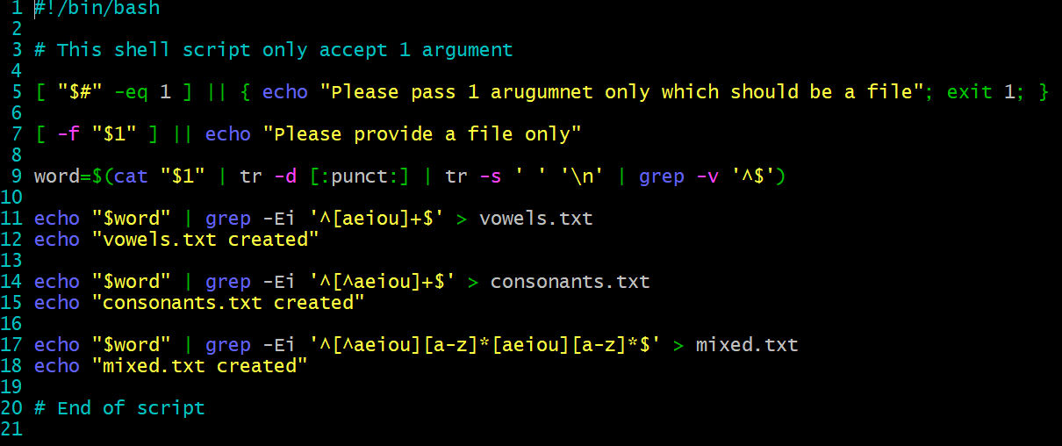
Wordfile.txt
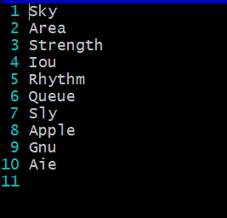
Files created:
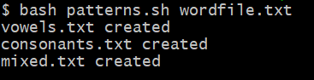
Vowels file
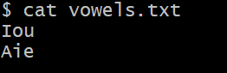
Consonants file
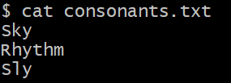
Mixed words file
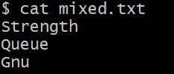
Explanation: Above scripts help to read a file and have proper error checks. After that it separate words in the file into different files depending on if they are vowel only, consonant or mixed words. I used grep with pattern match to find vowels and consonants. Then used redirection command to redirect outputs to its desired files. Followed the case sensitive constrains and all.

